39.27: a) We recall 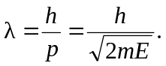 But the energy of an electron accelerated through a potential is just 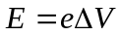
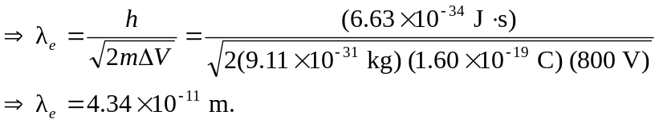
b) For a proton, all that changes is the mass, so
